# Using GPX Manager v 1.1.2

Prepared by

Rafael Martinez

GIS and Database Specialist

Consultant, SFP

## Introduction

GPX Manager is a windows application for managing track and waypoint data generated by GPS. GPS units are used to track movement of Blue Swimming Crab fishers. The location and time of important events such as lowering and hauling of gears are recorded using waypoints. Waypoints and tracking data are saved by the GPS in GPX files. GPX is an xml format adopted for GPS data ([Wikipedia](https://en.wikipedia.org/wiki/GPS_Exchange_Format)). GPX Manager will make it easy to save these files into a computer, transfer logbook data to the database, and visualize tracks and waypoints using a map.

### Requirements:

1. A copy of the GPX Manager installer (<https://github.com/raffyMartinez/GPXManager/releases>)
2. A PC with Windows installed (Windows 10 preferred)

### Optional:

1. A copy of the installer for MapWinGIS mapping component (<https://github.com/MapWindow/MapWinGIS/releases/tag/v4.9.6.0>) (optional)
2. MS Access installed in the computer

## Installing:

### Installing MapWinGIS

How MapWinGIS is installed is similar to how most software is installed in Windows. Just accept the default settings the installer is asking you.

### Installing GPX Manager

Most software that are installed in Windows are saved in the Program Files folder. For GPX Manager, it is recommended that the software is installed separately in its own folder. You could save it in **c:\GPXManager** or **c:\GPX** or any other folder name that you want. What is important is that by installing it in its own folder, it makes it easy to locate and update.

## Opening GPX Manager for the first time

The first time GPX Manager is opened, it needs to be setup.

|  |  |
| --- | --- |
| 1. Click on the setup button | setup button.jpg |
| 1. Provide the needed information  * GPX folder in computer – this is where backup of GPX files are saved in the computer * GPX folder in device – this is the folder in the GPS where GPX files are saved. For Garmin devices, use: **Garmin\GPX** * Path to backend database – locate the MDB file where data in GPX Manager is saved. * Hours offset from GMT – this is the difference (in hours) your location is from Greenwich Mean Time or GMT. The Philippines is 8 hours ahead of GMT so the default value is 8.  GPS stores time in GMT that is why this value is needed to bring GPS time to local time. * Bing API Key – the API key is a piece of random looking text that enables GPX Manager to show maps that are provided by Microsoft BING. * Number of latest trips to show – default is 5 * Number of latest GPX files to show – default is 5 | setrtings window.jpg |

## Enrolling GPS devices to the database

The serial numbers and device names of each GPS unit need to be saved in the database. This is done once for each device by enrolling them.

|  |  |
| --- | --- |
| 1. Connect one GPS unit to the computer using USB cable. To avoid confusion, enroll only one GPS unit at a time |  |
| 1. Press the Scan USB devices button | scan USB button.jpg |
| 1. The device that is recognized by windows is shown in the Devices tree view. | Recognized device with drive.jpg |
| 1. Fill up the form that is asking for information about the plugged GPS   Device name – the name that is assigned to the GPS  Device code – a short code that will identify your GPS.  Brand – select from the dropdown the GPS brand  Model – select from the dropdown the GPS model  Folder – the folder in the device where GPX data is saved.  As seen, Device ID is already detected by GPX Manager. This will be used as the primary ID of the device | form for GPS info.jpg |
| 1. When the GPS brand dropdown is empty, double click on the dropdown.  A new window will open.    This new window will allow you to make a list of GPS brands   Click on the Ok button to save the list. | list of GPS brands.jpg |
| 1. Back to the form, select a GPS brand from the dropdown. | Select from GPS brand.jpg |
| 1. Select model from the dropdown. If the list is empty, double click on the list so that you can enter one or more GPS models   Click on the Ok button to save the list | list of GPS models.jpg |
| 1. Back to the form, select the model from the dropdown |  |
| 1. Double click on the folder to select the folder in the GPS where GPX files are saved   Click on the save button to enroll the unit to the database. | provide GPX folder.jpg |
| When enrollment is successful, you will see this result.  device enrolled to database.jpg  In the device tree, you now see the assigned name of the device (**Ajuy 0015**). Below it, you will see a branch with the name of the folder where the GPX files are saved (**K:\Garmin\GPX**). You will see one or branches containing the months that represent a collection of GPX files whose time stamps belong to a month. In our example, there is a branch named **Oct-2020** and this contains GPX files collected within the month of October 2020.  The last branch that you will see is the **Trip log**. The Trip log will contain a list of Trips that are derived from GPX files contained in the GPS.  If you want, you can click on these branches to see the contents.  Using the Eject button, disconnect the GPS unit from your drive.  Enroll all GPS units following the steps just mentioned. | |

## Ejecting GPS device

When a device is ejected, the software ensures that any GPX file saved in the GPS will be backed up to the database. Later, you will find out a way to prove that the GPX files are now saved to the database. After a successful removal of a device from the computer, you will see this confirmation:

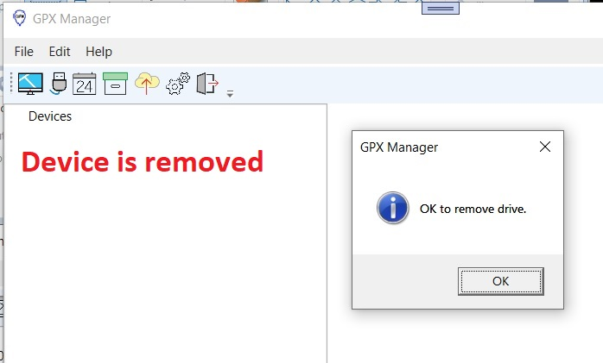

You will see that the GPS is removed from the Device tree on the left side plus a confirmation message is displayed.

## Viewing GPX data in the GPS

When you click on the GPX folder of the device, you will see a table with the latest GPX files. The table will show the **latest** **files only**. It will consist of the three newest track and three newest waypoint GPX files.

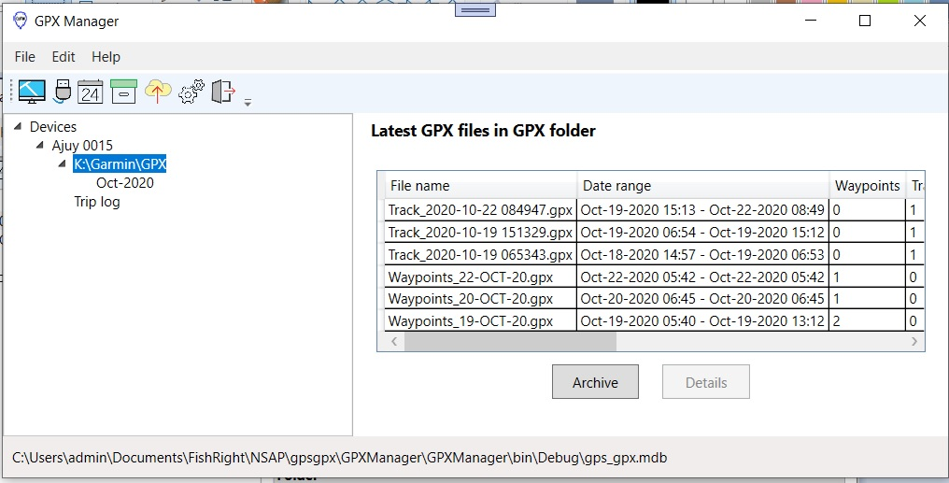

These are the columns in the table:

1. File name – the file name of the GPX file
2. Date range – the timestamps of the track or waypoints in the file
3. Waypoints – count of waypoints in the file. If the count is zero, it means that the file contains tracks
4. Tracks – count of tracks. If the count is zero, it means that the file only contains waypoints
5. Track points – number of points that make up the track. There should be at least 2 track points in a track
6. Time span – length of time between start of track and end of track. Expressed in number of hours and minutes
7. Length – length of the track expressed in kilometers
8. Trips – count of fishing trips that are based on the track
9. Mapped – if checked, it means that the GPX file is shown on the map
10. Archived – if checked, it means that the GPX is already backed up in the database
11. Size –size of the GPX file
12. Date created – date when the GPX file was created by the GPS
13. Date modified – date when the GPX file was modified by the GPS

## Viewing GPX data in the GPS by month

When you click on a month, you will see a table of GPX files that were collected for that month.

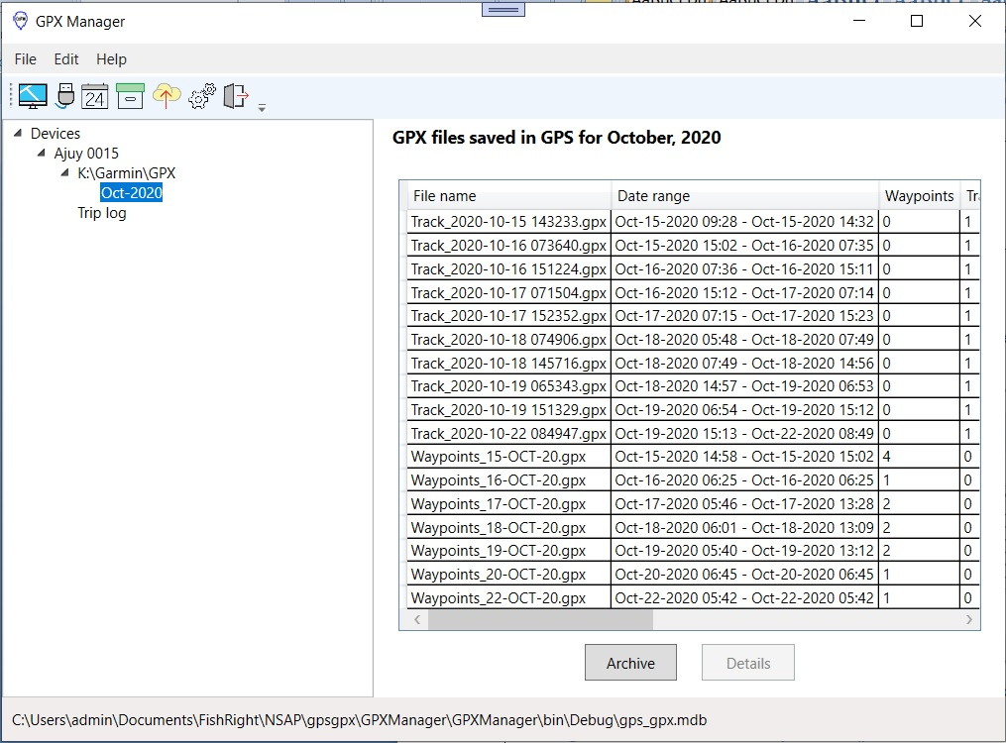

## Archiving GPX data

As seen in our previous examples, backing up GPX files to the database can be automatic. This will happen when the following occurs:

1. When a device is removed from the computer using the Eject button
2. When the application is closed, any GPX files in GPS devices connected to the computer will be backed up to the database.

Of course, you can archive data manually by pressing on the Archive buttons.

## Viewing archived GPX files

|  |  |
| --- | --- |
| 1. From the toolbar, click on the Archive button: | archive button.jpg |
| 1. You will see an archive tree that shows the following  A branch that shows a GPS whose files are backed up in the database (**Ajuy 0015**). Inside that branch are one or more month branches representing a set of files that were created during that month (**Oct-2020**) | archive tree.jpg |
| 1. Click on a month to see a table of GPX files.  table of archived files by month.jpg  The table will have the following columns: 2. File name – file name of the GPX file that is in the archive/backup 3. Date range – for waypoints, timespan consists of the earliest waypoint timestamp and the latest waypoint timestamp. For tracks, it consist of the earliest track point and the latest track point. 4. Waypoints – number of waypoints in the file, if zero then the file is a track GPX file. 5. Tracks – number of tracks in the file, if zero then the file is a waypoint GPX file. 6. Time span – for tracks, it is the length of time when the track was recorded until recording was stopped, It is expressed in number of hours: number of minutes 7. Length – for tracks, it is the length in kilometers 8. Trips – number of fishing trips that are based on the GPX file 9. Mapped – if checked, it means that the GPX file is displayed on the map | |

## View archived GPX data

|  |  |
| --- | --- |
| 1. To view the saved GPX in the archive, right click any row in the table.  Select **View GPX file** | view gpx right click menu.jpg |
| 1. A new window will open that shows the contents of the GPX file. | window showing GPX.jpg |
| 1. For a better view of the GPX content, double click the GPX text to see the content in Notepad. | gpx open in notepad.jpg |

## Importing GPS

One or more GPS units can be imported into the database using an XML file that contains the details of one or several GPS.

|  |  |
| --- | --- |
| 1. Click the Archive button in the toolbar | scan USB button.jpg |
| 1. Right click on Archive main branch on the device tree and from the shortcut menu select **Import GPS** | Import GPS context menu.jpg |
| 1. Provide the XML file that contains the data of the GPS to be imported | provide import gps xml file.jpg |
| 1. After successfully importing, the new GPS devices will be shown on the tree together with a confirmation message  Take note that imported GPS units are already enrolled into the database | success import GPS.jpg |

## Importing GPX files into the database

### Requirements

To be able to import GPX files into the database, the following conditions must be met.

1. A folder must exist that contains all the GPX data to be imported. Let us refer to this folder as the Main Folder.
2. Inside the Main Folder, one or more folders with each folder named after a GPS unit. Let us refer to any one of these folders as a GPS Folder. It is not necessary that the GPS Folder is a child of the Main Folder. It could be found in one or more subfolders deep into the hirerarchy.
3. A GPS Folder can contain files or more folders. It is important that the GPS Folder name refers to a GPS that is already enrolled in the database

### What will happen

The software will look at the contents of each GPS Folder. If it finds a GPX file, it will process that file, if it finds a folder, it will look at the contents of that sub-folder and process any GPX file. For each subsequent subfolder, the process will be repeated until no more folders are found.

### What is the result

Any GPX file that is successfully processed will be saved in the GPX archive of the database. The Archive tree will be updated to show the months where the GPX data fall into.

### Importing GPX files to the Archive

|  |  |
| --- | --- |
| 1. Click the Archive button in the toolbar | scan USB button.jpg |
| 1. Right click on Archive main branch on the device tree and from the shortcut menu select **Import GPX** | Import GPX context menu.jpg |
| 1. Provide the folder that contains the GPX files that will be imported to the database | locate folder for importing GPX.jpg |
| 1. After successfully importing GPX files, there will be a confirmation message.  The archive tree will be updated showing the months where the archived files fall into. | updated tree showing months in archive.jpg |

## Creating a fishing trip

A fishing trip is based on the tracks from a GPX file. You will add to this the data that are recorded in the logbook.

|  |  |  |
| --- | --- | --- |
| 1. Select a track GPX file that are listed in any of these two tables:   a) GPX folder of a connected GPS b) Archives of GPX files   Right click and from the shortcut menu select **Add trip based on track**. | add trip using track.jpg | |
| 1. A new window will open. This window is where you will encode the data written in the logbook.  Fill up the requested data: 2. Name of operator 3. Name of fishing vessel 4. Gear used – select the gear used from the dropdown 5. Other fishing gear – if the fishing gear is not listed, then you can type the name of the gear here. 6. Date and time of departure 7. Date and time of arrival 8. Notes 9. Trip identifier 10. GPS used 11. Track summary | add trip window.jpg | |
| 1. Press the **Extract track** button.  This will get that portion of the track that fits between time of departure and time of arrival.  Afterwards, a summary of the track will be shown in Track summary.  Double click on Track summary if you want to see the details of the proposed track.  Press the **Ok** button to save to the database. | filled trip window.jpg | |
| Back to the table of GPX files, you will now see that selected GPX file has been updated to show that it has 1 trip based on it. This means that the data in the GPX file was used to create the track for 1 fishing trip.   GPX table with trips recorded.jpg  **Questions** Does this mean that one GPX file can be used for more than 1 trip? Yes. As long as the current GPX file in the GPS is not removed, it will continue to track using the same file until the GPS detects that memory is full. Then it will overwrite earlier data in the track. Of course we will avoid getting to a point where GPS memory is reduced to a small size.  How do we manage multiple trips from one GPX file? In the logbook, we are asking date and time of departure and arrival to the landing site for each trip. If a GPX file contains multiple days of tracks, only those segments of the track whose timestamp fall in between the two dates and times will be saved.   What are the advantages of this feature? It means that there is no need to worry if we forget to delete GPX file after transferring them to the database. We also reduce usage of the buttons of the GPS thus increasing its lifespan.  How will this impact the workflow? By allowing the GPS to just collect GPX data for multiple fishing trips we can simplify our workflow and make it easier for everyone. So instead of erasing data from the GPS after these have been copied to the computer we can do this less frequently say once a week or once every two weeks. Additionally, instead of downloading data to a computer after every trip, we can do it less frequently say once a week. The reduced handling of the GPS will produce benefits such as increased lifespan of the mechanical parts of the GPS.  How do we adopt these to the workflow? Slowly until we are comfortable and confident that the software is really backing up the data. | | |
| Providing waypoints for a trip  1. Proceed to the **Trip log** branch of the current GPS. You will see another table containing trips that are saved to the database.  trip log branch.jpg   These are the columns in the table:   1. Trip ID – database identifier of the trip 2. Operator – name of the operator of the fishing vessel 3. Fishing vessel – name of the fishing vessel 4. Gear – gear used 5. Other gear – name of other gear used (this is used if the gear’s name is not on a preselected list of gear names 6. Departure - date and time of departure of the vessel from the landing site 7. Arrival – date and time of arrival of the vessel at the landing site 8. Track source GPX – name of the GPX file that is the source of tracking data for the trip 9. Waypoints – number of waypoints assigned to the trip. This will be zero for each new trip. 10. Summary – summary of the track of the vessel consisting of length in kilometers and duration (hours:minutes) | | |
| 2. Select any row. A new table will show up below the trips table.  add waypoints for a trrip.jpg This new table will contain the waypoints that are assigned to a fishing trip. For now this table is empty and our next step is to add waypoints for the selected tip | | |
| 1. To add waypoints, click on the **Add** button. A new window will open for inputting the needed information.  1. Waypoint name – select from the dropdown.  2. Waypoint type – select whether the waypoint marks set or hauling of gear 3. Timestamp – timestamp of the selected waypoint 4. Set # - if this is from the first set put 1, if second set, put 2, etc. 5. Trip ID – automatically generated 6. Source of waypoint – name of GPX file where the waypoints are taken. 7. ID –generated by the software  Press on the **Ok** button to save to the database | | provide waypoint window.jpg |
| 1. The table of waypoints is updated and the selected trip that had zero waypoints assigned to it before now has 1 (encircled).  updated waypoint table.jpg Repeat until all waypoints has been assigned to the selected trip. | | |

## Viewing a calendar view of fishing trips

|  |  |
| --- | --- |
| 1. Click on the Trip calendar button on the toolbar | calendar button.jpg |
| 1. You will see a tree view of saved trips. Clicking on any branch that is found inside Trip calendar allows you to view a calendar of fishing trips.  calendar view.jpg   When you double click on a day marked with an “x”, a window will open that shows the details of the selected trip. | |
| 1. This is the view of saved fishing trips per GPS.  trips by gps.jpg   When any row in the table is clicked, it will show the waypoints that were assigned to a trip.  trips by gps with waypoints.jpg   You can add add or edit waypoints to a saved trip. | |

## Mapping

With GPX Manager, you can visualize tracks and waypoints on a map. It is easy. Just right click on a GPX file and from the shortcut menu, click on a mapping menu.

### Mapping GPX files that are saved in GPS

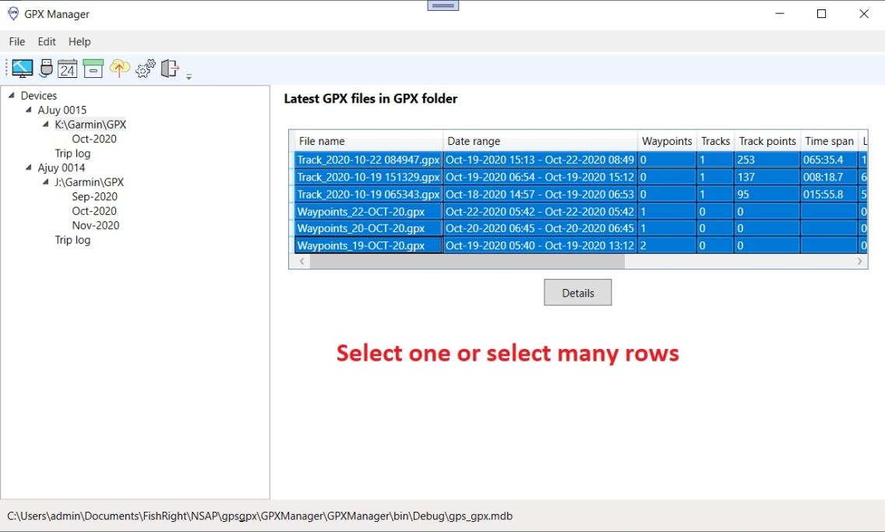

Right click on any of the selected rows and from the shortcut menu, select the mapping option.

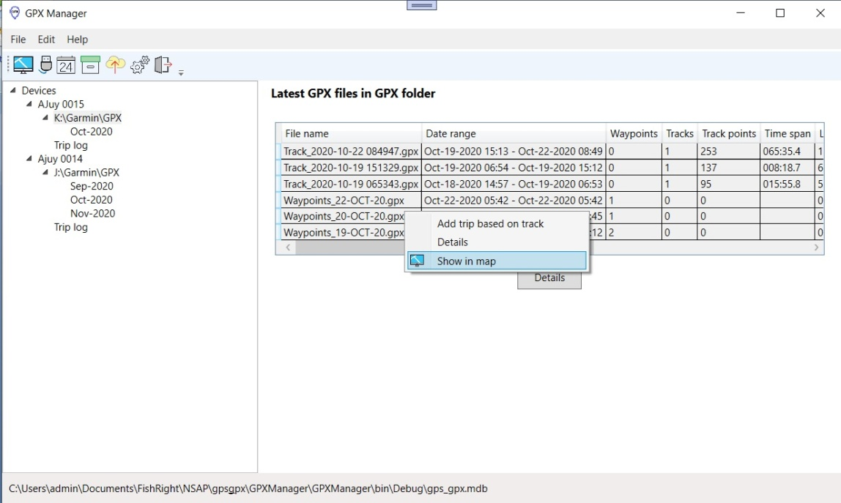

A map will open that will show the GPX files that were selected.

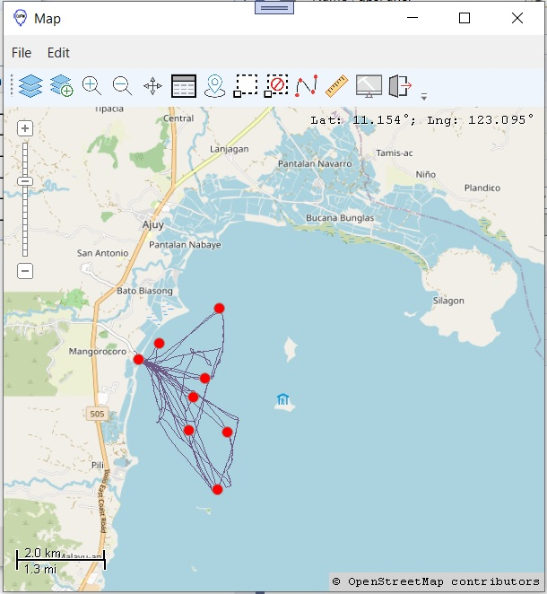

## The mapping toolbar

The mapping toolbar puts frequently used functions in one place.

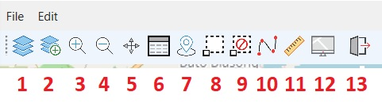

|  |  |  |  |
| --- | --- | --- | --- |
| 1 | Layers – opens the layers dialog | 8 | Select – click or drag to select one or more objects |
| 2 | Add layer – to be implemented in the future | 9 | Clear selection |
| 3 | Zoom in – drag or click to zoom in | 10 | Track – to be implemented in the future |
| 4 | Zoom out – click to zoom out | 11 | Measure – Click 2 or more points to measure distances on the map |
| 5 | Pan – drag to pan or move the map | 12 | Hide map – temporarily hide the map |
| 6 | Attributes – open the layer attributes window | 13 | Exit – closes the map |
| 7 | GPX – to be implemented in the future |  |  |
|  |  |  |  |

Some of the buttons are not yet implemented.

## Layers

Objects on the maps are grouped in layers. To see what layers are on the map, click on the Layers button that is found in the map toolbar.

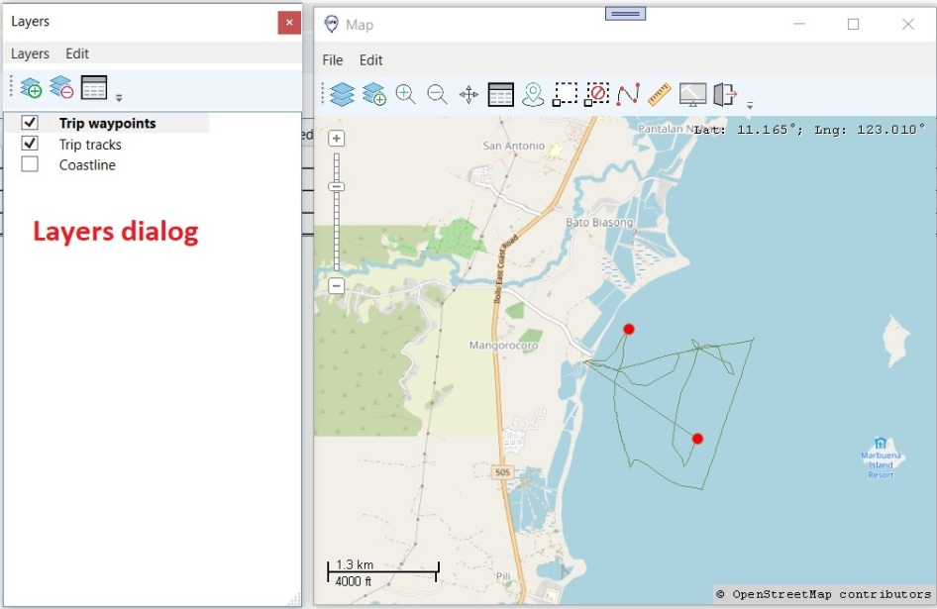

There are 3 layers listed. The coastline layer is not checked so it is not visible on the map. The name of the current layer is set in **bold** font. Operations such as selecting objects in the map and viewing attribute data only work on the current layer. To change the current layer, just click on another layer in the list.

These are the buttons in the toolbar of the Layers dialog.

|  |  |
| --- | --- |
| Layers dialog toolbar.jpg | 1. Add layer – to be implemented in the future 2. Remove layer - to be implemented in the future 3. Attributes – Shows the attributes of the current layer |

## Attributes

The objects that are listed in the Layers dialog and shown in the map contain attributes. To view attributes, click on the Attributes button that is found in the toolbar.

In our example below, we show the track of a fishing trip with 2 fishing waypoints. The attribute window is open showing the data behind these 2 waypoints. When we click a row on the Attribute window, the corresponding point on the map is highlighted. If we select a point in the map, the corresponding row in the table is selected.

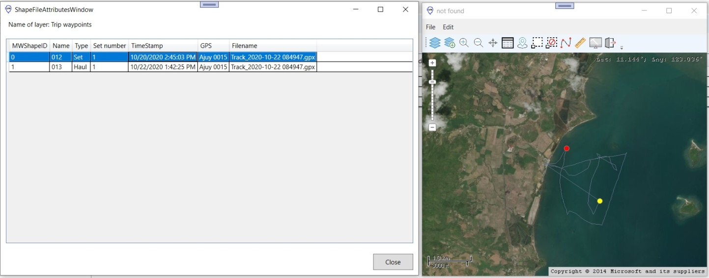

### Mapping trips that are saved in the database

Open the calendar view and from select an branch that is inside Trips by GPS.

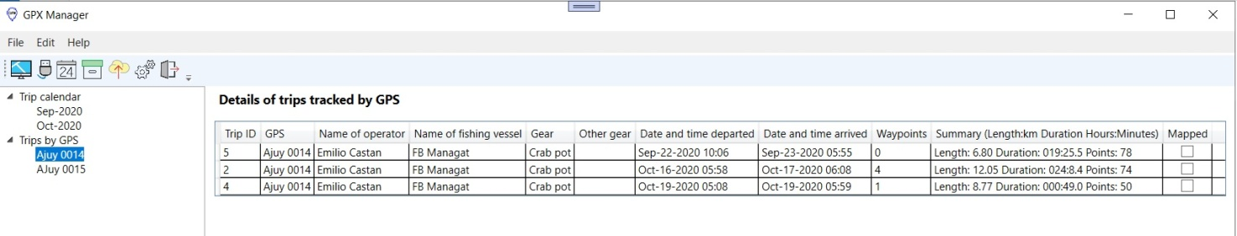

Click on the Open map button that is found in the toolbar.

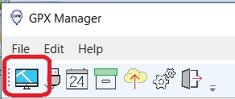

Select any row on the table. The track and waypoints for the selected trip will be shown on the map. If you click on another row on the table, the track and waypoints shown previously will be erased from the map and will be replaced by the currently selected trip.

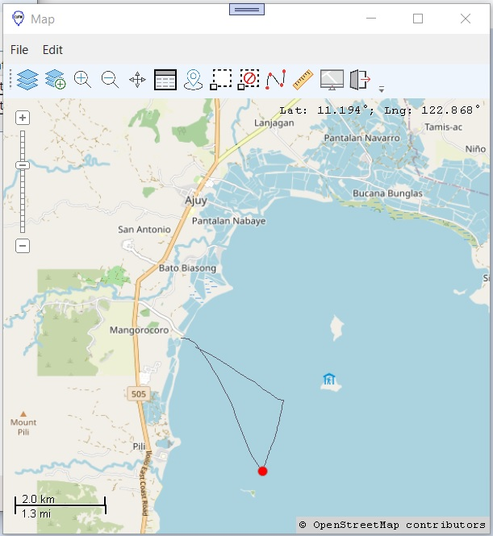

## Configuring the base map

GPX Manager can be configured to show different types of base maps. The default base map is that of the entire Philippines.

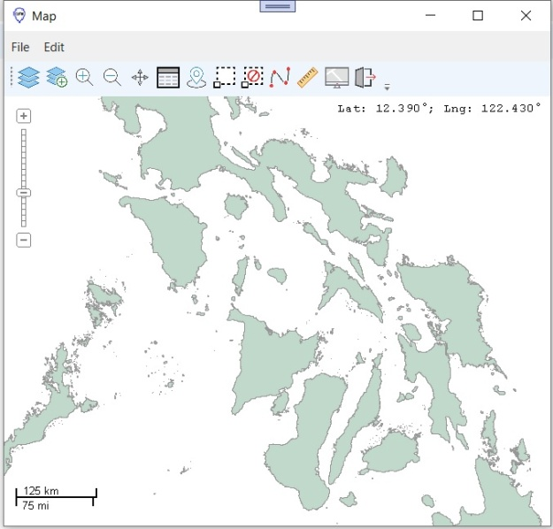

You can choose to show a basemap that is richer in terms of information that is displayed. However, this will work if there is internet.

Here is how this is done.

|  |  |
| --- | --- |
| 1. From the **Edit** menu of the mapping window, hide the coastline basemap. | coastline visible menu.jpg |
| 1. From the **Map tiles** menu, Check **Map tiles visible** | map tiles visible menu.jpg |
| 1. Select a provider from a list that is shown to you. | map tiles provider window.jpg |
| 1. If we select OpenStreeMap, our base map will look like this. | openstreetmap base map.jpg |
| 1. If we zoom in to our study site, we can see names of communities, roads, rivers, fishponds, and other familiar features.  The images (called tiles) that make up the map are saved locally in the computer. If these images exist in the computer, then there is no need to go online to fetch them from the server.  As long as the image cache is not deleted in the computer, basemaps such as that provided by OpenStreetMap will work offline. | zoom in openstreemmap.jpg |

## Backend database of GPX Manager

The data that is managed by GPX Manager, especially track and waypoint data that are created by partner fishers using GPS are ultimately saved in a backend database. That database is an MDB or a Microsoft Access Database. The folder or directory where the database is located can be seen at the bottom of the GPX Manager window.

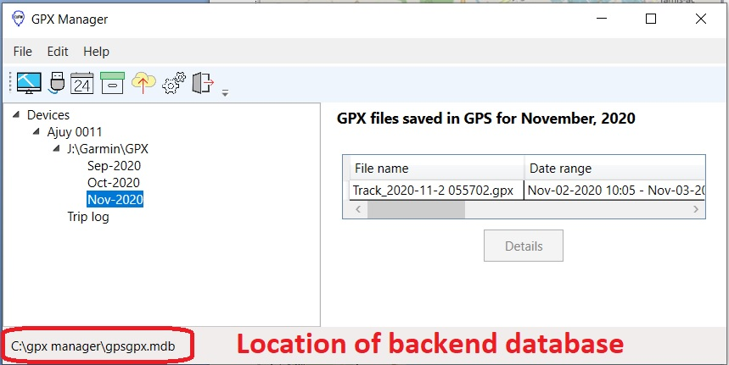

Double-click on the status bar that contains the name of the backend database to open the folder that contains the MDB file.

### Structure of the database

The database consists of 6 tables.

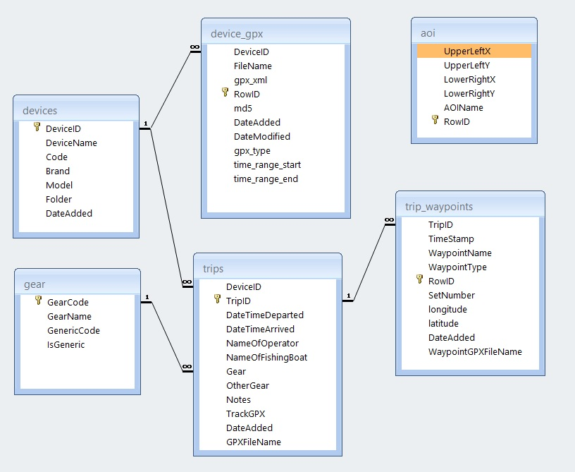

|  |  |
| --- | --- |
| **Table** | **Description** |
| devices | Holds the details of the GPS that is enrolled in the system |
| gear | Holds the names of fishing gears that is selected from a drop-down list |
| device_gpx | Holds backup copies of GPX files that are generated by GOX |
| trips | Holds details of fishing trips |
| trip_waypoints | Holds details of waypoints that are assigned to a fishing trip |
| aoi | Holds details of areas of interest |

Since the structure and fields of the database are self-explanatory, it would be useful to discuss how some of the tables work.

**devices** – as indicated, *DeviceID* is the primary key. This is the serial number that is detected by Windows when a device is plugged into the computer using USB. *Folder* is where the GPS saves the track and waypoint GPX files that are generated by the unit.

**device_gpx** - when the software archives or makes a backup of the GPX files that are in the GPS, it saves them to this table. The field *gpx_type* is used to indicate whether a file consists of tracks or waypoints. *DeviceID* tells us the GPS that is the source of the GPX file. The field *gpx_xml* is the actual content of the GPX file and is formatted using xml. To determine whether a gpx file has changed, the value stored in the *md5* field is used. The md5 algorithm is able to detect even a change of a single character in the gpx file. The *Filename* field saves the original filename of the GPX file.

**trips –** trip data for a fishing operation is saved in this table. The *TrackGPX* field holds an xml representation of the points that make up the track of an operation. TrackGPX is extracted from a GPX file using date and time of departure and arrival that is written in the logbook. If you want to know the coordinates of the track of a fishing trip then you have to look at the contents of the TrackGPX field.

**trip_waypoints –** thewaypoints that were created by the fishers to mark location of gear setting and hauling are saved in this table. The coordinates are stored in the *latitude* and *longitude* fields. *WaypointType* tells us if the waypoint was taken at setting or hauling of gear. Since a gear maybe set multiple times in a trip, the field *SetNumber* is used for this purpose.

**aoi** – to make locating fishing grounds in the map easier, we make use of AOIs or areas on interest. AOIs are rectangular areas that are defined using two longitude-latitude pairs. One pair describes the upper left hand corner of the rectangle and the other pair tells us where the lower-right corner is. AOIs are not used to enforce spatial limits. It is just a tool of convenience that makes it easy to mark an area on the map.

## Viewing GPX data saved in the database

As shown below, the location of the database is written on the bottom part of the GPX Manager window.



When the location is double-clicked, it will open the folder that contains the database.

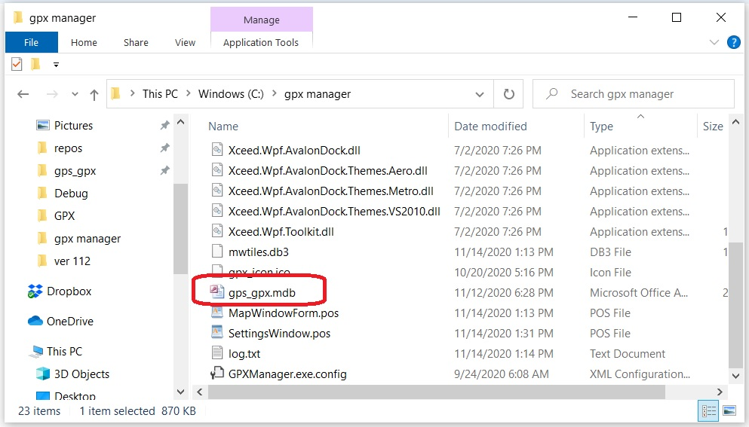

Locate the database and open it.

You will see a listing of tables inside the database.

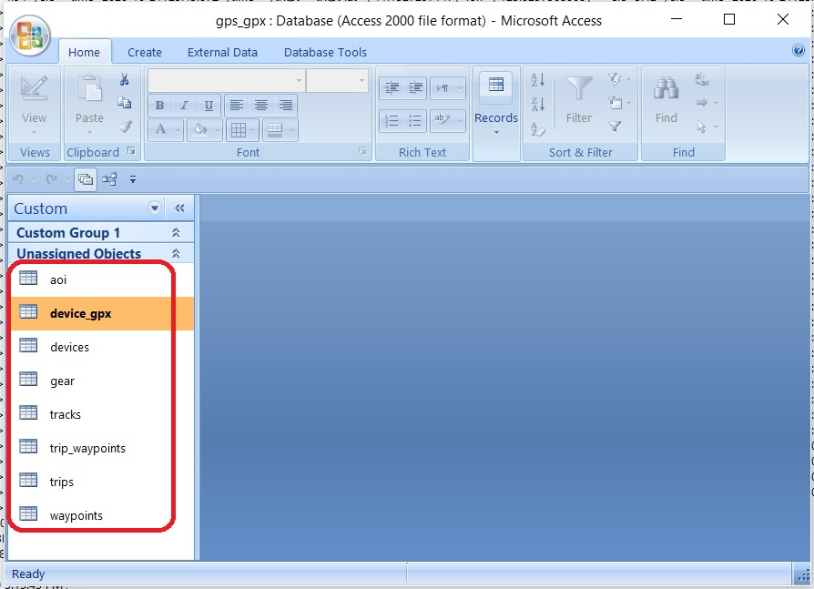

Double click on the table named device_gpx. This table contains the backup copies of GPX files from the GPS.

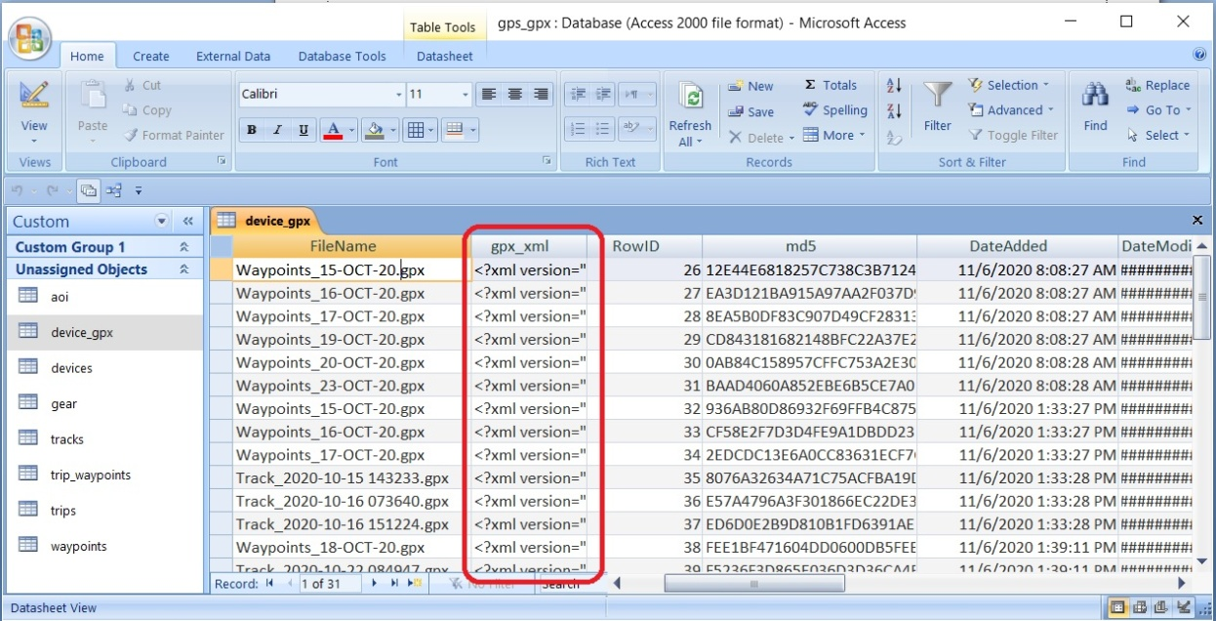

The GPX data is found in the column gpx_xml. To view the entire content of the xml file follow these steps.

1. Click on any cell either to the left or right of the gpx_xml column.  
   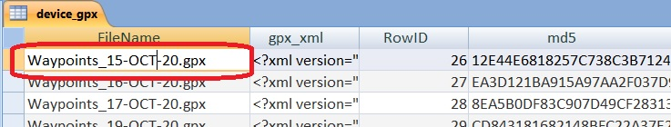
2. Using the arrow keys, select the cell containing the gpx data. The cell is highlighted with a dark color.  
   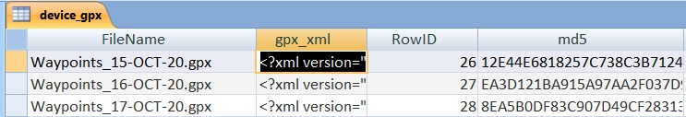
3. Right click and select Copy from the menu.  
   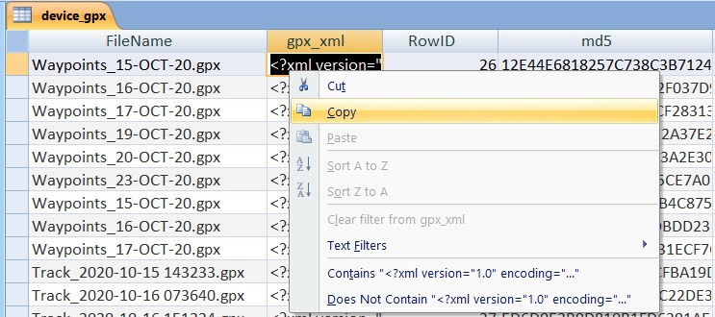
4. Open Notepad and paste. Compare the contents pasted in Notepad to the contents of the original GPX file that is in the GPS. They are the same.